Floodplain Mapping

The purpose of the floodplain mapping is twofold.
- First and foremost it is used to demonstrate to the Floodplain Administrator(s):
  - the extent of the project work,
  - that NDOT is aware of where the project encroaches upon floodplains, and
  - provides a connection to the discussion and certification of those encroachments.
- Secondarily, it is used to alert NDOT designers and staff to areas of potential conflict between project design and legal requirements that may require changes in design.

Community has Effective FIRM or FHBM Panels
- All floodplain mapping for a community with effective Flood Insurance Rating Map (FIRM) or Flood Hazard Boundary Map (FHBM) Panels must be produced from those panels.
- All mapping must be done in the form of FIRMettes produced by one of three methods (all available at no cost) from FEMA.
  - Method 1 is the use of the FEMA FIRMette Desktop Flood Map Image Tool
  - Method 2 is the use of the on-line FEMA Intranetix Viewer’s – Make a FIRMette tool (button). This tool (button) can be reached through the Map Service Center’s “View” option where the FIRM Panels are available for individual download.
  - Method 3 is the use of the on-line FEMA National Flood Hazard Layer Viewer “Print Flood Map” tool.
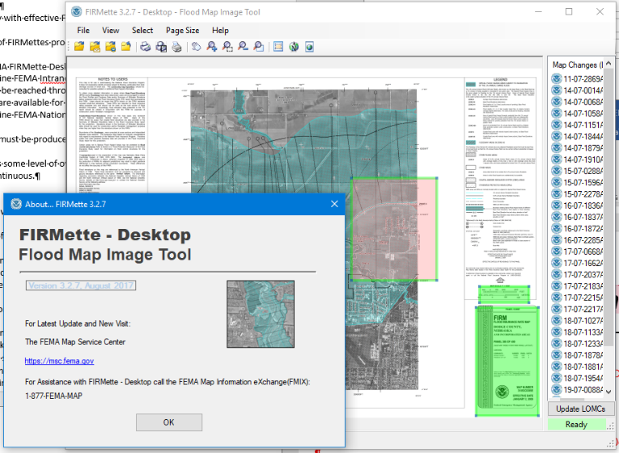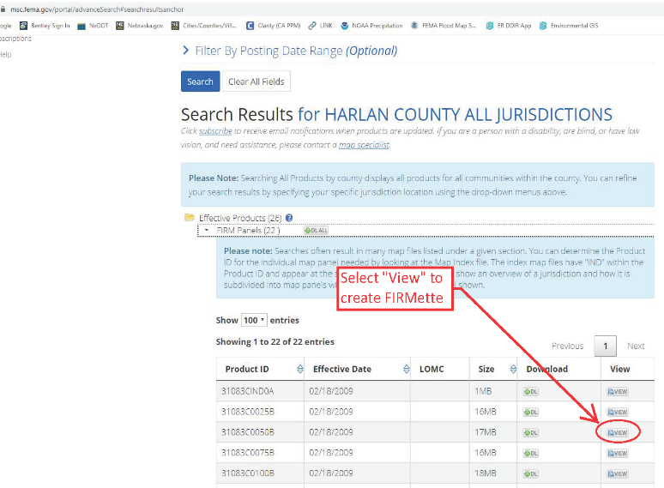
- Enough floodplain mapping FIRMettes must be produced so that the entire extent of the project is shown in the various FIRMettes.
  - It is recommended that there is some level of overlap between the panels so that it is evident that the mapping is continuous.
- The FIRMettes must show:
  - A scale bar;
  - FIRM Panel Number and Effective Date;
  - The Name of the Community;
  - If North is not toward the top of the FIRMette page, then a North Arrow must be provided;
  - Some reference to the map being a FIRM or FHBM, or associated with FEMA.
- Provide labeling in the FIRMettes. Break the labels in to “Informational” labeling and “Floodplain Encroachment” labeling.
  - The two labeling styles and colors must be uniform within themselves, and different from the other.
  - “Informational” labeling is recommended to be red (text, lines and shapes, leader boxes, and text boxes) with white background.
    - Solid, straight line style shapes are recommended
    - Text and line coloring must match.
  - “Floodplain Encroachment” labeling is recommended to be a mustard orange/yellow color (text, lines and shapes, leader boxes, and text boxes) with white background.
    - Solid, cloud line style shapes will be used.
    - Text and line coloring must match.
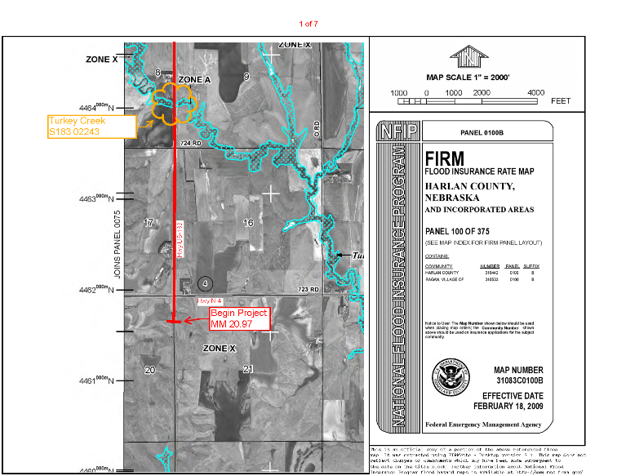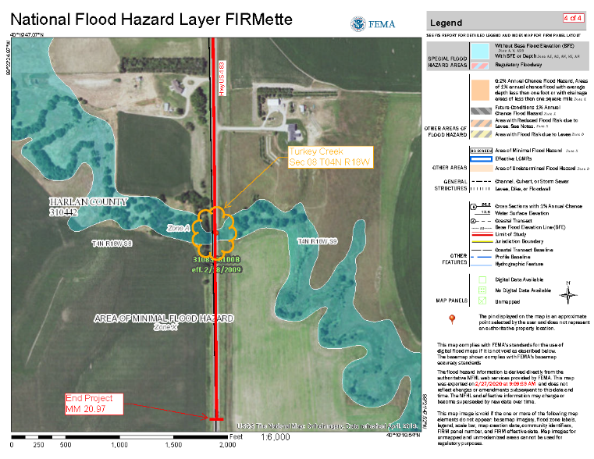
- The FIRMettes must be ordered and numbered sequentially, 1 through ‘n’, from one end of the project to the other.
  - Label each FIRMette with its sequential numbering in the format of:
<< PAGE of TOTAL PAGES >> (i.e. 1 of 7)
  - The text coloring will follow the “Informational” labeling format. (Adobe Acrobat has a Header & Footer function that can be used to generate this numbering, a recommended text size is 10 pt.)
  - Ordering preference is from Beginning of Project to End of Project, but is not required.
- The project’s extent / route must be traced across the FIRMettes, from its Beginning to its End.
  - If the project extent / route is across new alignment, or the FIRM mapping is older than the current existing highway alignment, provide your best approximation of the route.
  - The route tracing should be done with a medium weight line (Adobe Acrobat’s 3 pt) with a color that contrasts with the base mapping. Preferred tracing color is red.
- Identify the project end points.
  - At the ends of the project work, the highway tracing lines should end in a “cross-bar” type marker (Adobe Acrobat’s “butt” Line Ending)
  - The ends should be labeled (“Informational” format), using a text box with leader. Refer to the project’s Location Map, and label the end points as follows:
    - Begin Project – at the beginning of the project;
    - Stop Project – where work temporarily ends before the end of the project;
    - Resume Project – where work restarts after a temporary “Stop” point; and
    - End Project – at the end of the project.
  - The reference post / mile marker numbers should be included in the text box on the second line with the identifier “MM”.
  - A recommended text size is 12 pt.
- Label State Highways on the FIRMettes.
  - Label both the project highway, and any state highway(s) crossing or paralleling it.
  - Recommended labeling is the “Informational” format of text on back ground (use a non-bordered background), but other symbology can be used. (Recommended text size is 8 or 9 pt.)
    - Preferred wording in text format is “Hwy N-2” or “Hwy US-385” or “Hwy I-480”
    - The highway identifiers shown on the FIRM Panels are not acceptable replacements for the labeling.
  - Place labels so they do not cover up floodplains or other important reference points.
- Identify each floodplain encroachment.
  - Enclose the entire length/area of floodplain encroached upon by the project.
    - The extent of the encroachment is based on the floodplain and the highway’s route through it, not the structure(s) conveying the flow through the highway.
    - It may be necessary to divide up a floodplain into two or more encroachments based on how that floodplain is encroached upon. (Example: Stream parallels highway for a distance then crosses through it, then parallels it for a distance on the other side. This encroachment should be broken in to its three parts.)
    - Use the “Floodplain Encroachment” labeling style - cloud line style, mustard orange/yellow color.
  - Label the floodplain encroachment according to the waterbody producing the floodplain.
    - Waterbody Name
Location Identifier
(Optional third line: Culvert size and shape, or other secondary identifier)
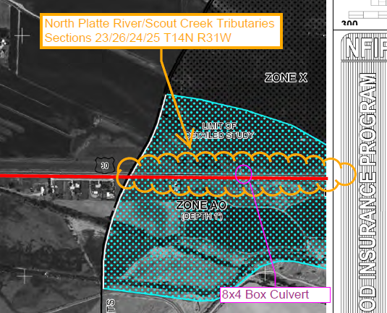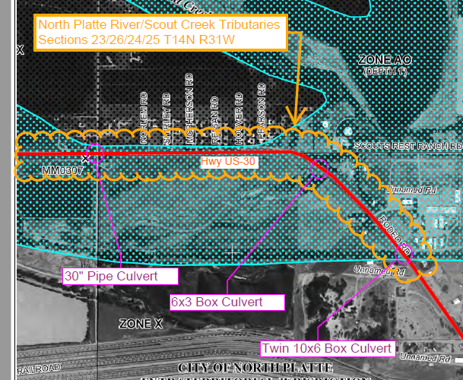
  - The floodplain encroachment label’s primary purpose is to connect the mapping to the certification memo discussion on that floodplain encroachment, and to the certification of compliance for the specific floodplain encroachment.
  - Floodplain encroachment waterbodies should be named one of four ways.
    - Named Waterbody– if the floodplain generating waterbody is actually named in the FIRM panel, on a topographic map, or on a State, County, or City map, then use that Name. (Example: Snake River, Turkey Creek, Lake Cunningham, Alkali Pond, Tri-County Canal, Tributary A, etc.)
    - Named Waterbody Tributary – if the floodplain generating waterbody is unnamed, evidently channeled, and flows directly in to a Named Waterbody, even if it is some distance away, then use the name of the Named Waterbody followed by Tributary. (Example: Platte River Tributary, Beaver Creek Tributary, Oak Lake Tributary, etc.)
    - Unnamed Tributary – if the floodplain generating waterbody is unnamed, evidently channeled, and flows in to another unnamed waterbody then use the label “Unnamed Tributary”.
    - Unnamed Drainage – if the floodplain generating waterbody is unnamed, is not evidently channeled, or is the final receiving body then use the label “Unnamed Drainage”. (This label can be modified, if desired, to better represent the waterbody, such as “Unnamed Pond”, “Unnamed Wetland”, etc.)
  - Do not label a floodplain as a “parallel encroachment”.
  - The Location Identifier is:
    - For locations where the floodplain crosses, and can be attributed in part by a bridge-sized structure – the State, County, or City structure number.
    - For all other locations - the Upstream Section(s), Township(s) and Range(s) of the floodplain.
    - See the encroachment header discussion in the Floodplain Certification Memorandum section below for additional information.
  - A third, optional line can be placed in the label if desired. This extra line can be used to provide a secondary identifier when multiple floodplain encroachments occur within the same Section, or for other tie-ins to the floodplain discussion and certification.
  - If the culvert size and shape are used they should be limited to:
    - Size – number and opening size of the culvert(s). Spell out inch and do not use the foot identifier (e.g. 72-inch, Triple 10x8).
    - Shape – basic style/shape of the culvert (e.g. Pipe Culvert, Box Culvert)
  - If the same floodplain encroachment shows up on two different pages due to overlapping of the FIRMettes, label the first appearance according to the labeling procedure above, and the second appearance as “See Page #”.
  - If the same floodplain encroachment shows up on multiple pages due to its length, label the floodplain on the page that makes the most sense (most floodplain, stream crossing, etc.) using the labeling procedure above, and the other appearances as “See Page #”.

Community does NOT have FIRM or FHBM mapping.
- State Minimum Standards require NDOT to consider flood hazards and losses in connection with state-owned and state-financed buildings, roads, and other facilities in communities without floodplain mapping.
  - NDOT floodplain policy is that drainages with watersheds greater than 640 acres, upstream of the highway, are subject to minimum state standards and will be treated as Base Floodplains.
  - NDOT floodplain policy is that drainages that the NeDNR has identified as Flood Awareness Areas or are shown within a Preliminary Flood Hazard Layer are subject to minimum state standards and will be treated as Base Floodplains.
  - State Minimum Standard mapping will be produced for projects within communities without effective FIRM or FHBM Panels to show compliance with the above policy.
- State Minimum Standard floodplain mapping (SMSFMap) for a community without effective FIRM or FHBM Panels must be produced from:
  - Base mapping that provide: (USGS Topographic Quadrangle maps meet these requirements as can maps produced from GIS software)
    - Topographic elevations, either by use of contours or elevation based coloration;
    - Streams/rivers;
    - Roadways;
    - Section delineators (i.e. Section/Township/Range)
  - Maps made from the NeDNR’s on-line Floodplain Interactive Map and that are obtained from areas where NeDNR has produced Flood Awareness Areas or Preliminary Flood Hazard Areas.
    - Not all un-mapped communities / locations have Flood Awareness Areas or Preliminary Flood Hazard Areas.
- All mapping must be created at a scale between 1:6000 ( 1-inch = 500 feet) and 1:12,000 ( 1-inch = 1000 feet)
- Enough State Minimum Standard floodplain mapping must be produced so that the entire extent of the project is shown in the various floodplain maps.
  - It is recommended that there is some level of overlap between the maps so that it is evident that the mapping is continuous.
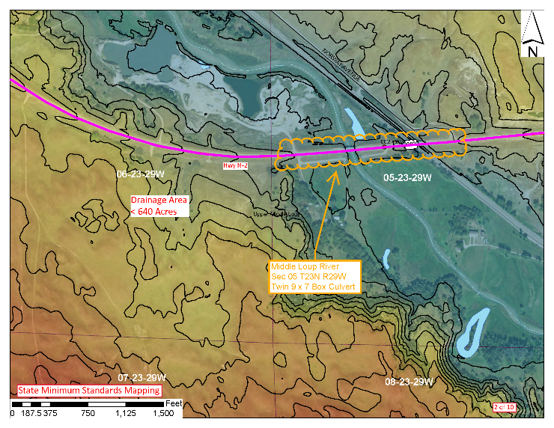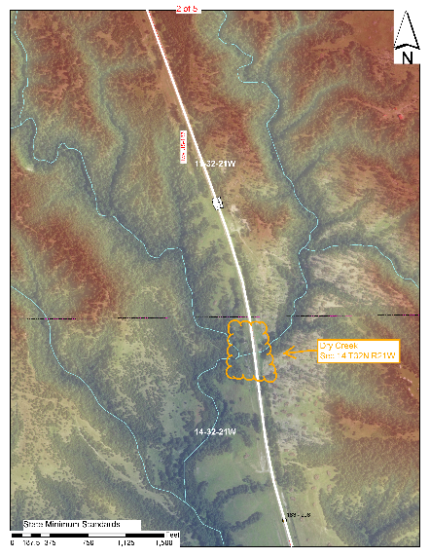
- The State Minimum Standard floodplain mapping will be labeled. That labeling will be broken up in to “Informational” labeling and “Floodplain Encroachment” labeling.
  - The two labeling styles and colors must be uniform within themselves, and different from the other.
  - “Informational” labeling is recommended to be red (text, lines and shapes, leader boxes, and text boxes) with white background.
    - Solid, straight line style shapes are recommended
    - Text and line coloring must match.
  - “Floodplain Encroachment” labeling is recommended to be a mustard orange/yellow color (text, lines and shapes, leader boxes, and text boxes) with white background.
    - Solid, cloud line style shapes will be used.
    - Text and line coloring must match.
- The State Minimum Standard floodplain maps must show:
  - A scale bar;
  - A North Arrow;
  - A label identifying the map as State Minimum Standards.
- The State Minimum Standard floodplain mapping (SMSFMap) must be ordered and numbered sequentially, 1 through ‘n’, from one end of the project to the other.
  - Label each SMSFMap with its sequential numbering in the format of:
<< PAGE of TOTAL PAGES >> (i.e. 1 of 7)
  - The text coloring will follow the “Informational” labeling format. (Adobe Acrobat has a Header & Footer function that can be used to generate this numbering, a recommended text size is 10 pt.)
  - Ordering preference is from Beginning of Project to End of Project, but is not required.
- The project’s extent / route must be traced across the SMSFMaps, from its Beginning to its End.
  - If the project extent / route is across new alignment, or the base mapping is older than the current existing highway alignment, provide your best approximation of the route.
  - The route tracing should be done with a medium weight line (Adobe Acrobat’s 3 pt) with a color that contrasts with the base mapping. Preferred tracing color is Red.
- Identify the project end points.
  - At the ends of the project work the highway tracing lines should end in a “cross-bar” type marker (Adobe Acrobat’s “butt” Line Ending)
  - The ends should be labeled (“Informational” format), using a text box with leader. Refer to the project’s Location Map, and label the end points as follows:
    - Begin Project – at the beginning of the project;
    - Stop Project – where work temporarily ends before the end of the project;
    - Resume Project – where work restarts after a temporary “Stop” point; and
    - End Project – at the end of the project.
  - The reference post / mile marker numbers should be included in the text box on the second line with the identifier “MM”.
  - A recommended text size is 12 pt.
- Label State Highways on the SMSFMap.
  - Label both the project highway, and any state highway(s) crossing or paralleling it.
  - Recommended labeling is the “Informational” format of text on back ground (use a non-bordered background), but other symbology can be used. (Recommended text size is 8 or 9 pt.)
    - The highway identifiers shown on the base mapping can be used assuming they are not obscured, and meet the “Informational” formatting.
  - Place labels so they do not cover up floodplains or other important reference points.

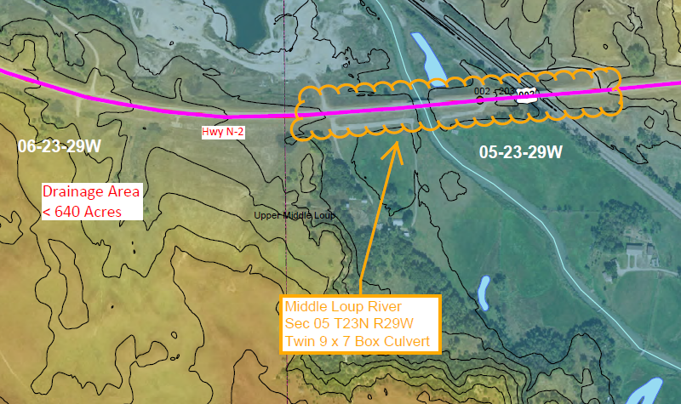
- Identify each floodplain encroachment.
  - Enclose the entire length/area of floodplain encroached upon by the project.
    - The extent of the encroachment is based on the floodplain and the highway’s route through it, not the structure(s) conveying the flow through the highway.
    - It may be necessary to divide up a floodplain into two or more encroachments based on how that floodplain is encroached upon. (Example: Stream parallels highway for a distance then crosses through it, then parallels it for a distance on the other side. This encroachment should be broken in to its three parts.)
    - Use the “Floodplain Encroachment” labeling style - cloud line style, mustard orange/yellow color.
  - Label the floodplain encroachment according to the waterbody producing the floodplain.
    - Waterbody Name
Location Identifier
(Optional third line: Culvert size and shape, or other secondary identifier)
  - The floodplain encroachment label’s primary purpose is to connect the mapping to the certification memo discussion on that floodplain encroachment, and to the certification of compliance for the specific floodplain encroachment.
  - Floodplain encroachment waterbodies should be named one of four ways.
    - Named Waterbody– if the floodplain generating waterbody is actually named on the topographic map, GIS system, or on a State, County, or City map, then use that Name. (Example: Snake River, Turkey Creek, Lake Cunningham, Alkali Pond, Tri-County Canal, Tributary A, etc.)
    - Named Waterbody Tributary – if the floodplain generating waterbody is unnamed, evidently channeled, and flows directly in to a Named Waterbody, even if it is some distance away, then use the name of the Named Waterbody followed by Tributary. (Example: Platte River Tributary, Beaver Creek Tributary, Oak Lake Tributary, etc.)
    - Unnamed Tributary – if the floodplain generating waterbody is unnamed, evidently channeled, and flows in to another unnamed waterbody then use the label “Unnamed Tributary”.
    - Unnamed Drainage – if the floodplain generating waterbody is unnamed, is not evidently channeled, or is the final receiving body then use the label “Unnamed Drainage”. (This label can be modified, if desired, to better represent the waterbody, such as “Unnamed Pond”, “Unnamed Wetland”, etc.)
  - Do not label a floodplain as a “parallel encroachment”.
  - The Location Identifier is:
    - For locations where the floodplain crosses, and can be attributed in part to a bridge-sized structure – the State, County, or City structure number.
    - For all other locations - the Upstream Section(s), Township(s) and Range(s) of the floodplain.
    - See the encroachment header discussion in the Floodplain Certification Memorandum section below for additional information.
  - A third, optional line can be placed in the label if desired. This extra line can be used to provide a secondary identifier when multiple floodplain encroachments occur within the same Section, or for other tie-ins to the floodplain discussion and certification.
  - If the culvert size and shape are used they should be limited to:
    - Size – number and opening size of the culvert(s). Spell out inch and do not use the foot identifier (e.g. 72-inch, Triple 10x8).
    - Shape – basic style/shape of the culvert (e.g. Pipe Culvert, Box Culvert)
  - If the same floodplain encroachment shows up on two different pages due to overlapping of the SMSFMaps, label the first appearance according to the labeling procedure above, and the second appearance as “See Page #”.
  - If the same floodplain encroachment shows up on multiple pages due to its length, label the floodplain on the page that makes the most sense (most floodplain, stream crossing, etc.) using the labeling procedure above, and the other appearances as “See Page #”.

Floodplain Certification Memorandum

The purpose of the floodplain certification memorandum is to assist the Floodplain Administrator in understanding the impact the highway project is having on the floodplain(s) within their community, and facilitate their approval of a NDOT Floodplain Permit. This is done by providing within the memo:
  - A synopsis of the project and the work to be completed by it;
  - A discussion about where the project encroaches upon base floodplains, the work being completed within the base floodplains, and a basis for why the work completed within the base floodplain does not violate the regulations/laws covering the base floodplains.

The target audience for the Floodplain Certification Memo is the local Village, City or County Floodplain Administrator, not NDOT staff. Floodplain Administrators come from many backgrounds and levels of understanding of highway terminology. The memo should be written so that the local administrator can understand what work is being completed within the floodplain; can understand what the impact is to the local floodplain; and will feel comfortable providing NDOT with a permit.

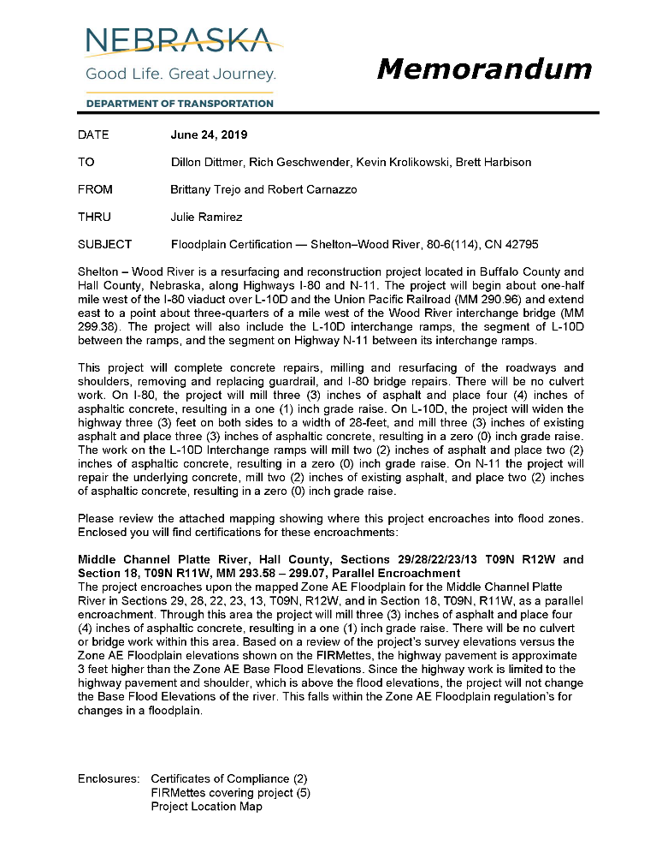
Memo Format
NDOT letter head is not a requirement for consulting firms. They may complete the memorandum using their own letter head.
- Font Types: Arial or Calibri are preferred.
- Font Size: 11 pt

- To/From/Subject
  - DATE
  - TO
  - FROM
  - THRU
  - SUBJECT line
- First Paragraph
- Second Paragraph
- Third Paragraph
- Encroachment Paragraph(s)
  - Community Header
  - Encroachment Header(s)
  - Encroachment Paragraph(s)
  - Next Community Header (if applicable)
  - Encroachment Header(s)
  - Encroachment Paragraph(s)
- Enclosures:
- Next Page: Permit Information

- To/From/Subject
  - DATE – Use the Date that the Memorandum was completed. Format is MONTH DD, YYYY (e.g. January 01, 2020).
  - TO – Dillon Dittmer, NDOT Designer, NDOT Unit Head, NDOT EPU Coordinator
    - Designer for consulting firms is the NDOT Consultant Coordinator.
    - Unit Head is the NDOT Consultant Coordinator Unit Head
  - FROM – The Memorandum Writer and/or Certifying Engineer
  - THRU – Julie Ramirez and Jason Dayton
  - SUBJECT line is: Floodplain Certification – Project Name, 000-00(0000), CN 00000
    - NDOT Project number format does not include the funding lettering
    - NDOT Project Control Number may include a following letter value

- The First Paragraph is used to locate the project for the Floodplain Administrator. It should use common terms and names, and local references for Starting and Stopping locations.
“PROJECT NAME is a PROJECT TYPE (e.g., Mill and Overlay, Resurfacing, New & Reconstruction, etc.) project located in COUNTY County, Nebraska, along Highway NUMBER (e.g. N-21, US-183, L-53A, S-14C, I-480). The project will begin DESCRIBE WHERE PROJECT BEGINS (Mile Marker (MM) 000.00) and extends DIRECTION to DESCRIBE WHERE PROJECT ENDS (MM 000.00).”
  - Think this through, do not just repeat the project description.
  - PROJECT NAME is the NDOT project name.
  - PROJECT TYPE examples are given, but can differ from these. Please be sure that they correctly identify the general project work to be done. Try not to be too technical in the type naming.
  - DESCRIBE WHERE PROJECT BEGINS/ENDS using references that will be familiar to, or easily determined by the local Floodplain Administrator (e.g. use city street or county road names, and distances in feet).
    - It is okay to be approximate or general in nature.
    - In rural areas without regular roadways, Section Township Range values may be appropriate.
    - In rural areas it may occasionally be acceptable to use the name of a property owner/ranch name when starting or ending adjacent to rural driveways.
  - Mile Marker or Reference Post values of the beginning and ending points are given for Consultant, NDOT and FHWA referencing (that is why they are in parentheses).
    - The values also help to tie the FIRMette locations to the Location Map.
    - Values are given in decimal format rather than in Stationing format.

- The Second Paragraph is used to describe the highway improvements to be completed by the project. Again, it should be aimed at the Floodplain Administrator and use common words and terms. If the work changes along the way, give local references for where the work changes like is done with the project beginning and ending points.
“The highway improvements on this project consist of DESCRIBE. “
  - Describe evidently different work items with pertinent details.
    - However, you do not need to provide details about, or even describe, everything being done on the project.
    - Example: …repair of underlying concrete pavement, milling and resurfacing the roadway and surfaced shoulders, resurfacing driveways and intersection, and culvert work. The project will remove by milling four (4) inches of existing asphalt and place a four (4) inch asphalt overlay, resulting in a zero (0) inch grade raise. Select culvert will be extended to both the north and south.
      - Note, no reference is made to the mill and overlay depth of the shoulders.
  - Be sure to describe work that can, and in the view of a non-technical individual, may impact the depth of the floodwaters.
  - Describe work items that will be evidently different from others. (E.g. the trenching and placing of beveled edging differs enough from mill and overlay work that it should be noted. – I call it “pavement edge improvement” to limit the effort of describing the work and make it less technical.)
  - The paragraph style can change depending on what needs to be covered.
  - Think this through, do not just repeat the project description.
  - Remember your audience is usually a non-technical individual with minimal experience in highway construction.

- The typical Third Paragraph is”
“Please review the attached mapping showing where this project encroaches into flood zones. Enclosed you will find certifications for these encroachments: “
  - If the project has a significant amount of work within a community without floodplain mapping the appropriate following paragraph will precede the above typical Third Paragraph.
- Add the following paragraph for Communities without mapping and ARE NOT participating in NFIP
“COMMUNITY NAME has no FEMA Floodplain mapping and does not participate in the National Flood Insurance Program (NFIP). NDOT policy in unmapped communities is to classify drainages with greater than 640 acres of watershed upstream of the highway and drainages that the Nebraska Department of Natural Resources has identified as Flood Awareness Areas as Potential Base Floodplains. State Minimum Standards require that all activity within potential Base Floodplains meet a “Less Than 1-foot Rise” criteria. A Permit is not required from the non-participating community, the certification(s) provided for the location(s) discussed below that meet this criteria will be retained in its stead. “

- Add the following paragraph for Communities that ARE participating in the NFIP but are not mapped
“COMMUNITY NAME has no FEMA Floodplain mapping, but does participate in the National Flood Insurance Program (NFIP). NDOT policy in unmapped communities is to classify drainages with greater than 640 acres of watershed upstream of the highway and drainages that the Nebraska Department of Natural Resources has identified as Flood Awareness Areas as Potential Base Floodplains. State Minimum Standards require that all activity within potential Base Floodplains meet a “Less Than 1-foot Rise” criteria. Certifications are provided for such locations. ”

  - If there is only a single floodplain encroachment within an unmapped community, the appropriate paragraph from above may be worked in to the discussion on that specific encroachment, rather than placing it as part of the typical third Paragraph.

- Encroachment paragraphs are used to identify where the project encroaches upon Base Floodplains, and what the effect that encroachment will have on the Base Floodplain Elevations (BFEs) of those Base Floodplains.
  - Encroachments are based on the Base Floodplains, and the extent over which the highway is in contact with the Base Floodplain. They are NOT based on the culvert or bridge structures of the highway.
    - A single encroachment can range from having no drainage structure to many.
  - The Encroachment paragraphs are formatted as follows:
Community Header - Underlined text
Encroachment Header(s) - Bold text
Encroachment Paragraph(s) - Standard Paragraph Formatting

“Community of COMMUNITY NAME
WATERBODY NAME, S000 0000 OR Section 00 T00N R00E/W, (optional: culvert size and shape)
The project encroaches upon the Base Floodplain for WATERBODY in Section 00, T00N R00E/W. The waterway’s ordinary high water flow is conveyed through (the highway by a pipe/box culvert with NUMBER (#) of SIZE openings OR the highway by a 000-foot long bridge). At this location the project will SUMMARIZE PROJECT WORK OCCURING WITHIN THE FLOODPLAIN. EXPLAIN THE HYDROLOGY AND HYDRAULICS OF THE ENCROACHMENT. SUMMARIZE THE IMPACT OF THE PROJECT ON THE BASE FLOOD ELEVATION OF THE WATERBODY.

  - Encroachment paragraphs are broken out into the community(s) responsible for their floodplain permit.
    - Multiple encroachment discussions can occur under each community header.
    - Encroachments discussed under a specific community header will be discussed in the order they occur in the floodplain mapping.
    - There should only be one discussion per encroachment. If an Encroachment crosses through multiple community territories, then the community header should include the names of each of the communities crossed through.
  - The Community Header format is:
    - Community of COMMUNITY NAME
    - There is only one Community Header per community.
    - Acceptable Community Names are:
      - Village of NAME,
      - City of NAME,
      - NAME County, and
      - NAME Indian Tribe.
  - The Encroachment Header(s) format is:
    - WATERBODY NAME, S000 00000 OR Section 00 T00N R00E/W
      - Optionally a culvert size and shape may be added to the end of the header.
      - Limit culvert size to the culvert inlet opening dimension.
      - Spell out inch, do not use the apostrophe as a foot identifier in the label.
      - Identify the shape as “Pipe” or “Box”
      - e.g. 36-inch Pipe Culvert, 8x5 Box Culvert, Twin 42-inch Pipe Culvert
    - Encroachments associated with bridge-size structures will use the bridge number format – S000 00000.
      - Multiple bridge numbers can be used if there are more than one bridge structure within the encroachment
    - Encroachments associated with all the other situations (nonbridge-sized culverts or no culverts) will use the Section-Township-Range format.
      - Multiple sections can be referenced.
      - Where a highway is located along a Section Line, the upstream Section Number(s) will be referenced.
    - The Encroachment Header should match the leader used to identify the encroachments in the FIRMettes.
      - The matching requirement is specifically to help the floodplain administrator connect the floodplain mapping showing the encroachment, to the floodplain memo discussing the encroachment, and then to the Certification of Compliance form.
      - Waterbody names are limited to “Named Waterbody”, “Named Waterbody Tributary”, “Unnamed Tributary”, and “Unnamed Drainage”. See the Floodplain Mapping sections above for the four naming conventions.
  - The Encroachment discussion paragraph is used help the floodplain administrator understand the situation occurring within the floodplain encroachment. It is used to inform/confirm to the floodplain administrator the type of floodplain encroached upon; inform them how the water is currently conveyed through / along the highway; let them know the specific project work that will occur within the floodplain; and provide them with a discussion on the hydrology and hydraulics of the encroachment and how that impacts the floodplain. The paragraph should end with a concise summation of the project’s impact on the base floodplain elevation.
    - WATER BODY – give the name of the water body with which the floodplain is associated. This should be the same as the one in the encroachment header.
    - NUMBER and SIZE – for encroachments associated with culverts this should describe the type and size of the culvert. Describe the number of openings in a multiple barrel culvert, the diameter of a pipe culvert, the width by height of a box culvert, spelling out the dimensions (e.g. 72-inch or 10-foot wide by 10-foot high). For encroachments associated with bridges the total span of the bridge between abutments is used.
      - Please write out numbers that are less than 10 and follow the written number with the number in parenthesis (e.g. two (2)).
      - Additional information such as “steel girder bridge” or “corrugate metal pipe” is extraneous and does not help the floodplain administrator understand the situation.
      - If the encroachment does not cross the highway or occurs at a location without a bridge or culvert, try to describe it
    - SUMMARIZE PROJECT WORK… - as it says.
      - Limit the description to just the work at the specific encroachment.
      - Can be a repeat of wording used in the Second Paragraph, or can be a more concise explanation than in the Second Paragraph.
      - State if there is or is not work that is completed on culverts or channels used to convey the flood waters.
    - EXPLAIN HYDROLOGY AND HYDRAULICS – provide a summary of the hydrology and hydraulics analysis of the existing floodplain, and how the project work impacts the conveyance of the base flood (see examples for various ways to phrase this).
      - See item g below.
      - If elevations are given, provide the elevation datum (NGVD 29, NAVD 88, local datum, etc.)
    - SUMMARIZE THE IMPACT ON BFE – Provide a concise, one sentence summation of the encroachment’s impact on the Base Flood Elevation.
      - Provide an actual estimated value of change to the BFE. Do not generalize to “< 1-foot”.
      - If there is no change in BFE then state it as “no change” rather than as “zero (0) increase”.
      - The change can be negative.
      - If there is any increase in a Floodway or greater than 1-foot in any other Base Floodplain (A, AE, AO, etc.), notify the Roadway Hydraulics Unit and the Bridge Hydraulics Unit, immediately.
  - The level of Hydrology and Hydraulics (H&H) analysis completed for a floodplain certification can differ based on the potential impact on the floodplain’s Base Flood Elevation.
    - No Analysis – Assumed overtopping. This is the easiest situation for the Certifying Engineer. The work within the encroachment does not include culvert replacement(s) or extension(s), or the extension(s) are minor; bridge work is limited to repair work without channel improvements; and any overlays that increase the overtopping elevation of the highway or bridge deck are four (4) inches or less. There are no residences or businesses located immediately up stream (800 feet per inch of increase) of the highway
      - A minor culvert extension is defined here as < 10 feet on a side, < 15 feet total, and with an inlet elevation change < 0.15 foot.
      - Other work that does not impact how flood water is conveyed through or over the highway is acceptable.
      - For parallel floodplains the highway embankment grading is limited to the highway shoulders and any culvert extension is limited to the placement of flared end sections.
      - H&H analysis is not generally necessary. The Certifying Engineer can assume overtopping is occurring under these conditions. It is assumed that any increase in base flood elevation is equal to the increase in pavement overtopping elevation.
      - Example phrasing:
“Assuming the base flood overtops the highway, the one (1) inch increase in the pavement elevation will cause an equivalent one (1) inch increase in the base flood elevation. The project will cause a one (1) inch increase in the base flood elevation of the WATERBODY NAME.”
    - As-Built Data Analysis. The Certifying Engineer can in many instances use NDOT as-built plans as a source of information on some floodplain encroachments. The as-built plans can help determine if the base flood will overtop the highway and/or bridge, or be conveyed whole by the highway structures.
      - Be sure that the as-built plan data has not been superseded by a later project.
      - Do not just accept the discharges and elevations provided on plans prior to 1990. Drainage policies and procedures prior to the 1996 Manual differed significantly from the current methods.
      - Determine the elevation datum (NGVD 29, NAVD 88, local datum, etc.)
      - Example phrasing:
“An analysis completed for the construction of the box culvert in 2002 indicates that the base flood (100 year event) of 2600 cfs is conveyed by the box culvert at a base flood elevation (BFE) of 1860.6 feet (NGVD 29), which is below the highway elevation of 1871.5 feet.”
    - Basic Analysis – Desk top level H&H, based on NDOT Procedures. When the work within an encroachment is such that the Certifying Engineer cannot or does not desire to assume overtopping, then in most cases a basic analysis using desktop H&H analysis can be used.
      - A desktop H&H analysis completes work, using sources available via office means: e.g. aerials, USGS maps, and LiDAR for drainage areas; LiDAR, existing survey and as-built plans for culvert sizes, flow lines and overtopping elevations.
      - The H&H analysis follows standard NDOT procedures.
      - For nonbridge-sized structures NDOT recommends using the Rational Method for drainage areas <640 acres and the NRCS curve number method for drainage areas from 1 to 10 sq. miles.
      - Follow standard Bridge Hydraulics procedures for bridge and bridge-size structure hydrology.
      - For most floodplain certifications, NDOT recommends using standard hydraulic procedures for determining the highway project’s impacts on the floodplain crossing (i.e. HY-8 for the culvert crossings, HEC-RAS for bridges, and normal depth Manning’s Equation calculations for channel impacts).
      - HEC-RAS should be used where longer channel impacts are expected or backwater from changes due to the highway project could reasonably impact upstream buildings.
      - Example phrasing:
“An analysis completed for this certification indicates that the base flood (100 year event) of 560 cfs overtops the highway at a base flood elevation (BFE) of 3597.3 feet (NAVD 88). The one and one-half (1.5) inch increase in pavement elevation will increase the BFE by an equivalent one and one-half (1.5) inches to an elevation of 3597.4 feet (NAVD 88).”
    - Full Analysis - On rare occasions, it will be necessary to complete significant additional work, a full analysis, to determine the impact that a highway project will have on the floodplain. Such work could include a flow line survey of the drainage way, a survey level cross-sectioning of the drainage/floodplain, site visits, obtaining floodplain study documents, detailed back water analysis, etc. Engineers should discuss such locations with the Roadway and Bridge Hydraulics units before starting this level of effort. Consultants are instructed to contact their Bridge or Roadway Design Coordinator before estimating/completing this level of effort.

- Enclosures - End the body of the Certification Memorandum with a listing of the enclosures included with the memo.
  - Certificates (#) - Provide the number of Certifications of Compliance issued with the memorandum.
  - FIRMettes covering project (#) – Provide the number of FIRMettes that were created to show the extent of the project. This includes any State Minimum Standards maps.
  - Location Map – If a location map is included, show that it is enclosed. If more than one is provided, include the (#) value after the text.

- Permit Information - End the Certification Memorandum with a summary of the information that will be requested for the floodplain development permit.
  - The Permit Information section will start a new page.
  - Title the Section as “Permit Information:”
“Community of COMMUNITY NAME
WATERBODY NAME, Section 00 T00N R00E/W, (optional: culvert size and shape)
Is the work substantial improvement? No/Yes
Is the work in an identified floodplain? No/Yes
Elevation of the base flood (100-year event)? 0000.0 NGVD 29/NAVD 88
Elevation/floodproofing requirement (if applicable)? NA
Is the work in a designated floodway? No/Yes “
  - Use the same break down of Communities and Encroachments as is done in the body of the memorandum.
  - Use the same Community Headers and Encroachment Headers provided in the body of the memorandum.
  - Substantial Improvement – Answer this as “Yes” only if the cost of the work being completed within the Encroachment would exceed 50% of the cost to rebuild the highway at this location.
    - This would only normally occur when the culvert / bridge / highway is being reconstructed.
    - Full replacement of the highway pavement qualifies.
  - Identified floodplain – Answer this “Yes” for all Base Floodplains, including those identified using State Minimum Standards.
  - Elevation – If the Base Flood Elevation (BFE) is known for the encroachment, provide that elevation value here.
    - Provide the pre-project elevation, and include the elevation datum.
    - If the hydraulics is based on the assumption that overtopping is occurring
  - Floodproofing – this should be NA (not applicable).
    - If the project work includes a building, this may need to be provided.
  - Designated Floodway – this will only be “yes” when work is being done within a mapped Floodway.
    - There are no floodways in unmapped State Minimum Standards communities.

